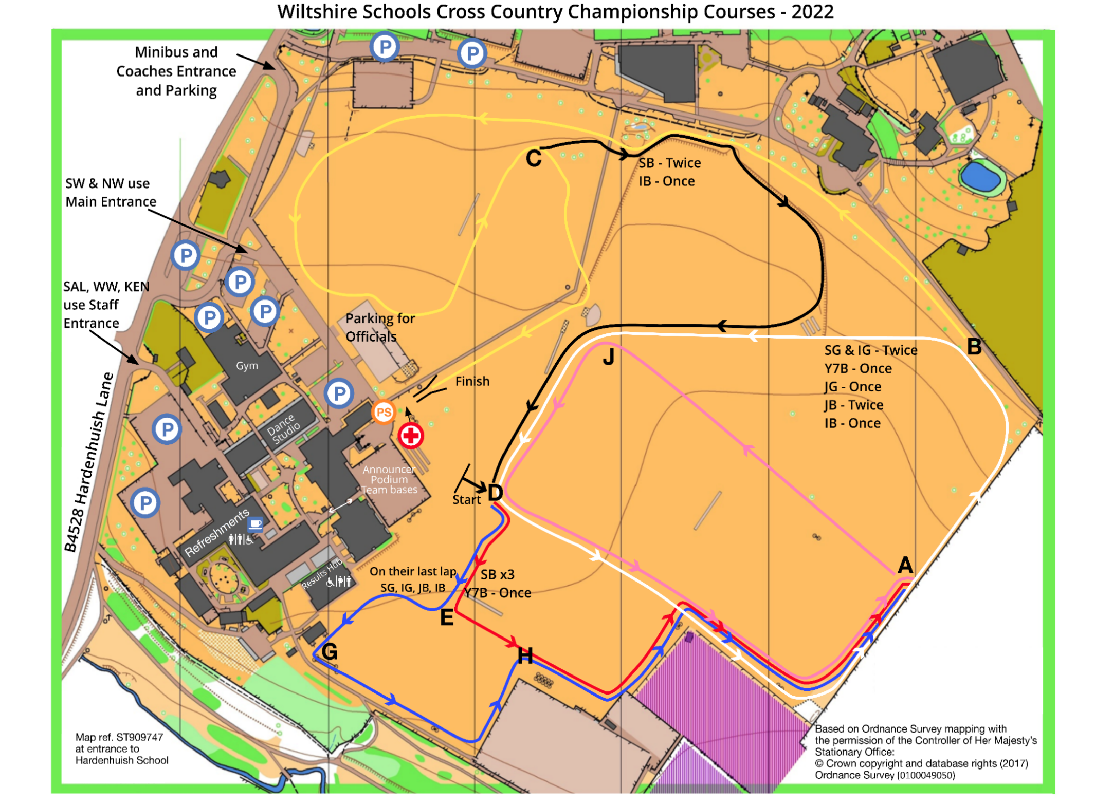

**Entrance B**

**Sign posted**

**Sheldon Sch main entrance**

**Ent: A**

**Sign posted Service entrance**

**Overflow**

**Parking:**

Turn left when coming out of the school.

At the double mini roundabout,

turn right. Then left down Hungerdown lane.

Lidl will appear on your right.

SN14 0JW

Park in Lidl but check how long is allowed (3 hours?). We hope to negotiate a special period. TBC

First Aid

**Please do not park on the grass.**

After parking, please ensure you go to one of the positions marked PS (Programme sellers) and pay the **entry fee of £2** (under 18 free) Thank you.

**Spectators** are directed to the spectator area marked on the map. If you move around the course, please do so using the crossing points and respect the school site by keeping off pitches. Thank you.

**Refreshments:** Don’t miss out on the Wow cakes and hot drinks on sale from the refectory. WSAA hope you have an enjoyable championship and wish you a safe journey home.

**Spectators**

PS

PS

PS

**Entrance to Hardenhuish School. Additional parking for SWS XC.**